KAIte (kīte)
Team: Team BlackBox

Architecture Design:
For the design of the architecture of KAIte, we used a Model-View-Controller architecture to separate the UI, logic, and data into distinct components. This separation simplifies the processes of maintaining, testing, and adding new features to the application. Additionally, it helps improve security and performance by limiting how important data can be accessed and providing natural divisions where parallelization can be implemented.

Architecture Design Diagram:
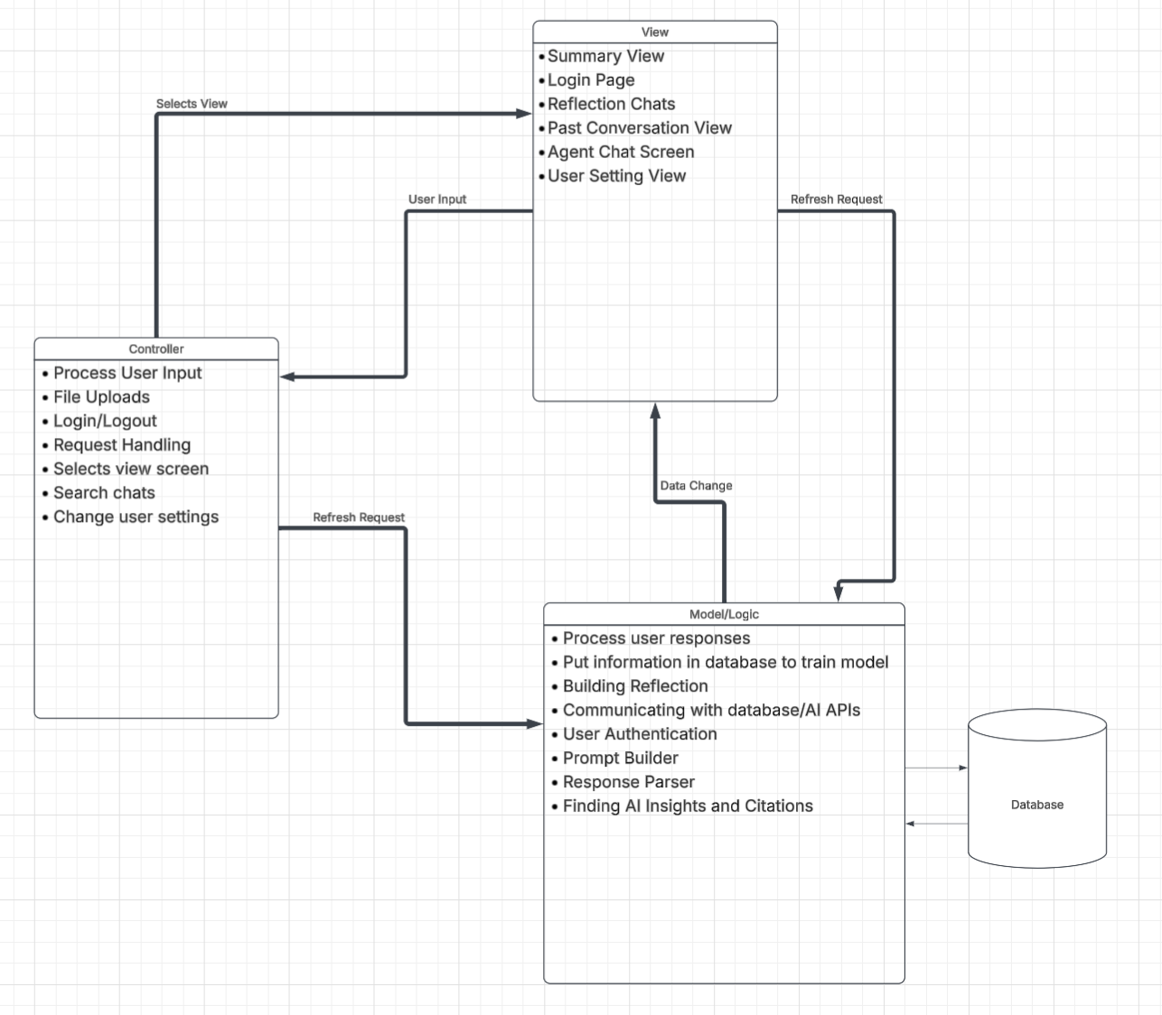

Design Description:
The architectural pattern consists of three components: the view, the controller and the model.
The view for KAIte handles the user interface of the web application. This is primarily implemented using React and TypeScript, which allow the interface to be organized into reusable components with type-safe data handling. The application will have many views, including a Login view, a main Dashboard, Reflection Conversation view, and a Practice Mode view. The Reflection [Conversation] view allows users to discuss their A.I. usage with a reflection agent, while the Practice [Mode] view gives users the ability to get general-purpose agent responses containing intentional, monitored errors for the user to catch. User interactions, such as submitting messages, starting a practice session, or navigating between the different views will trigger events that send the appropriate information to the controller. Tailwind.css will be used to provide flexible styling that works well on mobile devices.

The controller for KAIte handles events originating from the view and coordinates the application's business logic. It will be implemented using Node.js and TypeScript, with Express.js providing HTTP endpoints for operations such as starting reflection conversations, submitting practice questions, retrieving conversation histories, and managing user sessions. When a request is received, the controller will validate the input, verify the user's identity and permissions, and determine which operations are necessary. Requests requiring A.I.-generated responses will be sent to Claude through a server-side integration, ensuring that API credentials are not exposed to the browser. The controller will then process the response, coordinate any necessary data storage, and return the result to the view.

The model handles KAIte's application data and its interaction with persistent storage. Firebase will provide the primary infrastructure for authentication and data storage, since its NoSQL database is well-suited to storing long chunks of relatively unstructured text like reflection conversations. Firebase’s server-side permission checks keep user data secure, and it also includes an authentication service for managing user identities. Firebase Storage can be incorporated to store uploaded files or other user-provided content.

